Supplementary material
Table S1: Number of papers about temporal lag in ecological responses to landscape change published per journal between January 2009 and August 2017.
Journal | # of papers
Biological Conservation | 10
Landscape Ecology | 6
Ecography | 5
Diversity And Distributions; Journal Of Applied Ecology; Journal Of Vegetation Science; Oecologia; Plant Ecology; Plos One | 4
Agriculture Ecosystems & Environment; Biodiversity And Conservation; Ecology And Evolution; Ecology Letters; | 3
Biological Invasions; Forest Ecology And Management; Insect Conservation And Diversity; Journal Of Ecology; Landscape And Urban Planning; PeerJ; PNAS | 2
Ambio; American Journal Of Botany; Animal Biology; Animal Conservation; Applied Vegetation Science; Biota Neotropica; Bmc Ecology; Conservation Biology; Current Biology; Ecological Applications; Ecological Indicators; Ecological Management & Restoration; Ecology; Ecoscience; Emu; Folia Geobotanica; Global Environmental Change; Journal Of Biogeography; Journal Of Mammalogy; Natureza & Conservação; Oikos; Pedobiologia; Restoration Ecology; Science; Scientific Reports | 1

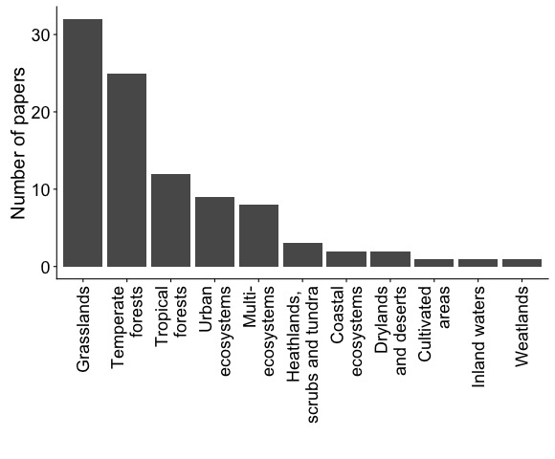
Figure S1: Number of papers published between January 2009 and August 2017 about temporal lag in ecological responses to landscape change at different ecosystems.

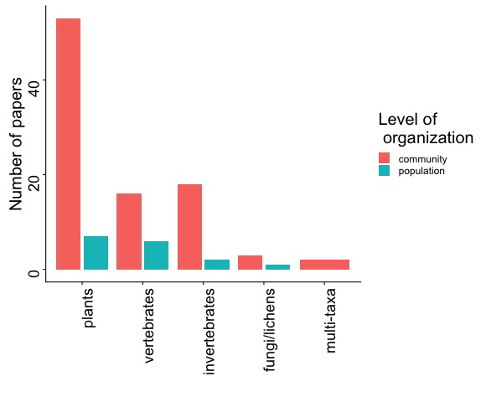
Figure S2: Number of papers about temporal lag in ecological responses to landscape change published between January 2009 and August 2017 using data of different taxa and level of organization.

